**EV MARKET SEGMENTATION ANALYSIS**

**-UDDHAV SALLA**

**Abstract**

The Indian electric vehicle (EV) market presents a diverse landscape, characterized by a range of models with varying performance metrics, affordability, and technological capabilities. This study analysis key parameters such as acceleration, top speed, range, efficiency, and price to segment the market and uncover actionable insights. The findings highlight significant trends, including the affordability-driven adoption of compact EVs, increasing interest in efficient and high-range vehicles, and the dominance of the SUV body style. With an average range of 338 km and an average price of €55,811, the study identifies opportunities for cost-optimized models to cater to the Indian market's price-sensitive consumers. This segmentation serves as a foundation for policymakers and businesses to address infrastructural challenges and align offerings with consumer needs, ultimately driving India's transition to sustainable mobility.

**Introduction**

India’s electric vehicle (EV) market is witnessing unprecedented growth as environmental concerns, government incentives, and advancements in technology converge to redefine mobility. With a diverse population and varying economic strata, market segmentation plays a critical role in identifying consumer preferences, optimizing offerings, and addressing challenges unique to the Indian automotive landscape.

This study examines key performance indicators from a dataset of EV models, including range, efficiency, acceleration, and price, to segment the market and understand emerging trends. Key statistics reveal that the average EV offers a range of 338 km, with prices ranging from €20,129 to €215,000, reflecting a broad spectrum of affordability and performance. While SUVs dominate the market, compact and mid-segment EVs show potential for mass adoption, given their practicality and cost efficiency.

The Indian EV market is currently shaped by the dominance of two- and three-wheelers, which address urban mobility needs, and a gradual rise in four-wheeler adoption among eco-conscious consumers. This analysis identifies gaps in affordability, infrastructure, and performance that need to be addressed to unlock the full potential of the EV market. By understanding market segmentation, stakeholders can better align strategies to accelerate the adoption of EVs in India.

**Columns:**

1. **Brand**: Vehicle manufacturer (e.g., Tesla, Volkswagen).
2. **Model**: Specific vehicle model.
3. **AccelSec**: Acceleration in seconds (0-100 km/h).
4. **TopSpeed_KmH**: Top speed in kilometers per hour.
5. **Range_Km**: Driving range in kilometers.
6. **Efficiency_WhKm**: Energy efficiency in watt-hours per kilometer.
7. **FastCharge_KmH**: Fast-charging speed (km of range added per hour).
8. **RapidCharge**: Whether the car supports rapid charging (Yes/No).
9. **PowerTrain**: Drivetrain type (e.g., AWD, RWD).
10. **PlugType**: Charging port type (e.g., Type 2 CCS).
11. **BodyStyle**: Vehicle design (e.g., Sedan, SUV).
12. **Segment**: Vehicle segment (e.g., B, C, D).
13. **Seats**: Number of seats.
14. **PriceEuro**: Price in Euros.

**Key Metrics:**

* **Performance:**
  + **Acceleration (0-100 km/h):** Ranges from 4.6 seconds (e.g., Tesla Model 3) to 10 seconds (e.g., VW ID.3).
  + **Top Speed:** Ranges from 145 km/h to 233 km/h.
  + **Energy Efficiency:** Varies between 161 Wh/km to 206 Wh/km, indicating a mix of highly efficient and less efficient vehicles.
* **Range and Charging:**
  + **Driving Range:** The range extends from 170 km (e.g., Honda e) to 450 km (e.g., Tesla Model 3).
  + **Fast Charging Speed:** Varies widely from 190 km/h (slow) to 940 km/h (fast).
  + **Rapid Charging Support:** Majority of vehicles support rapid charging, while a few do not.
* **Market Segmentation:**
  + **Price:** Prices range from €30,000 to €68,000, targeting mid-range to premium market segments.
  + **Body Style:** Includes Sedans, SUVs, Hatchbacks, and Liftbacks.
  + **Seats:** Most vehicles are 5-seaters, with some compact models offering 4 seats.
* **Segment Distribution:**
  + Segment B (Compact): Includes smaller cars like Honda e.
  + Segment C (Mid-size): Includes practical vehicles like VW ID.3.
  + Segment D (Premium): Features higher-performance models like Tesla Model 3 and Polestar 2.

**Segmentation:**

**1. By Price:**

* **Affordable (<€35,000):**
  + Vehicles like Honda e and VW ID.3 target budget-conscious buyers.
* **Mid-range (€35,000–€55,000):**
  + Includes Polestar 2 and Tesla Model 3.
* **Premium (>€55,000):**
  + BMW iX3 and similar luxury models.

**2. By Range:**

* **Short-range (<250 km):**
  + Focus on urban commuters (e.g., Honda e).
* **Medium-range (250–400 km):**
  + Balances daily use and occasional trips (e.g., VW ID.3).
* **Long-range (>400 km):**
  + Ideal for long-distance travelers (e.g., Tesla Model 3).

**3. By Energy Efficiency:**

* **Highly Efficient (<170 Wh/km):**
  + Economical vehicles with low energy consumption.
* **Moderately Efficient (170–190 Wh/km):**
  + Balanced performance and efficiency.
* **Less Efficient (>190 Wh/km):**
  + Power-focused or larger vehicles.

**4. By Body Style:**

* **Sedans:** Target professionals and long-distance drivers.
* **SUVs:** Focus on families or outdoor enthusiasts.
* **Hatchbacks:** Designed for urban and compact spaces.

**Data Collection:**

The data is collected from different online sources which includes Kaggle , data.gov.in , Chatgpt , Google ,GitHub

<https://www.bing.com/ck/a?!&&p=7dfae9154b841ba3a63f264874f1e6039169aa98b1bbaae02357707a9f5dc192JmltdHM9MTczNzY3NjgwMA&ptn=3&ver=2&hsh=4&fclid=17bceccb-bb21-6659-38c9-fd70bac96726&psq=chat+gpt&u=a1aHR0cHM6Ly9jaGF0Z3B0LmNvbS8&ntb=1>.

<https://github.com/>

<https://www.kaggle.com/datasets>

<https://www.data.gov.in/>

<https://datasetsearch.research.google.com/>

**Data Representation:**

**Image 1 (Imports and Loading Data):**

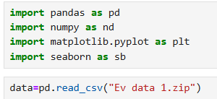

* The code imports essential Python libraries for data analysis and visualization:
  + pandas for data manipulation.
  + numpy for numerical operations.
  + matplotlib.pyplot and seaborn for data visualization.
* The pd.read_csv() function is used to load a dataset from a compressed .zip file named "Ev data 1.zip". This dataset is likely related to electric vehicles (EVs).

**Image 2 (Filter: TopSpeed > 200 Km/H):**

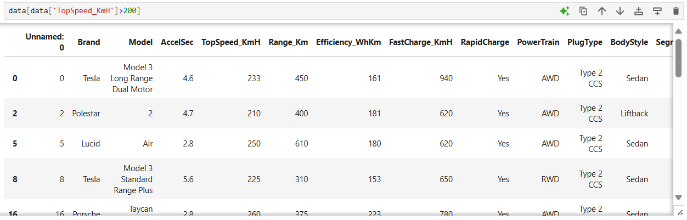

* The dataset is filtered to display rows where the TopSpeed_KmH column exceeds 200 km/h.
* Key observations:
  + The filtered data shows high-performance EVs from brands like Tesla, Polestar, Lucid, and Porsche.
  + These cars have top speeds ranging from 210 to 260 km/h, demonstrating the capability of premium EVs in terms of speed.
  + Models include Tesla's Model 3 (Long Range Dual Motor and Standard Range Plus), Polestar 2, Lucid Air, and Porsche Taycan.

**Image 3 (Filter: Price > €50,000):**

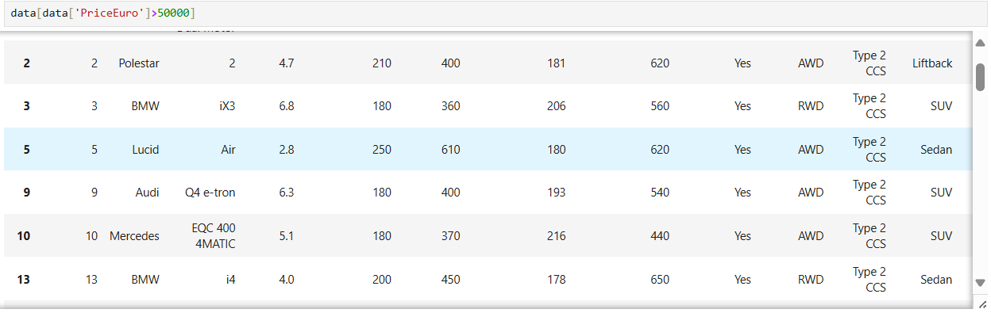

* This filter extracts rows where the PriceEuro column exceeds €50,000.
* Key observations:
  + High-priced EVs include models from luxury brands such as Polestar, BMW, Lucid, Audi, and Mercedes.
  + These vehicles typically offer premium features, longer ranges (up to 610 km for the Lucid Air), and advanced performance metrics (e.g., acceleration under 3 seconds for some).
  + Body styles vary from sedans (Lucid Air, Tesla Model 3) to SUVs (BMW iX3, Audi Q4 e-tron).

**Image 4 (Filter: Price < €50,000):**

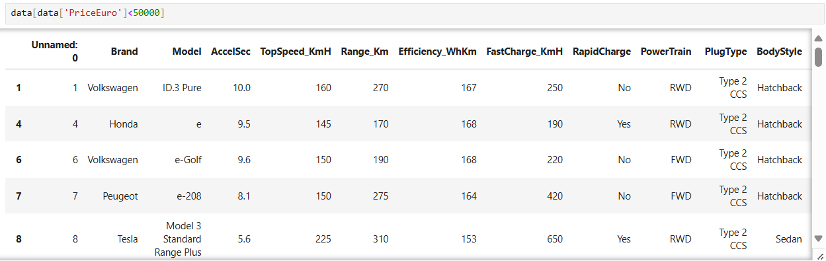

* This filter retrieves rows where the PriceEuro column is less than €50,000.
* Key observations:
  + More affordable EVs are listed, including Volkswagen ID.3 Pure, Honda e, Volkswagen e-Golf, and Peugeot e-208.
  + These models typically have lower top speeds (145-225 km/h) and shorter ranges (170-310 km) compared to the higher-priced EVs.
  + They are well-suited for city commuting and budget-conscious consumers.
  + Most of the vehicles are compact hatchbacks, except for Tesla's Model 3 Standard Range Plus (sedan).

**Data Visualization:**

**Image 1: Correlation Heatmap**

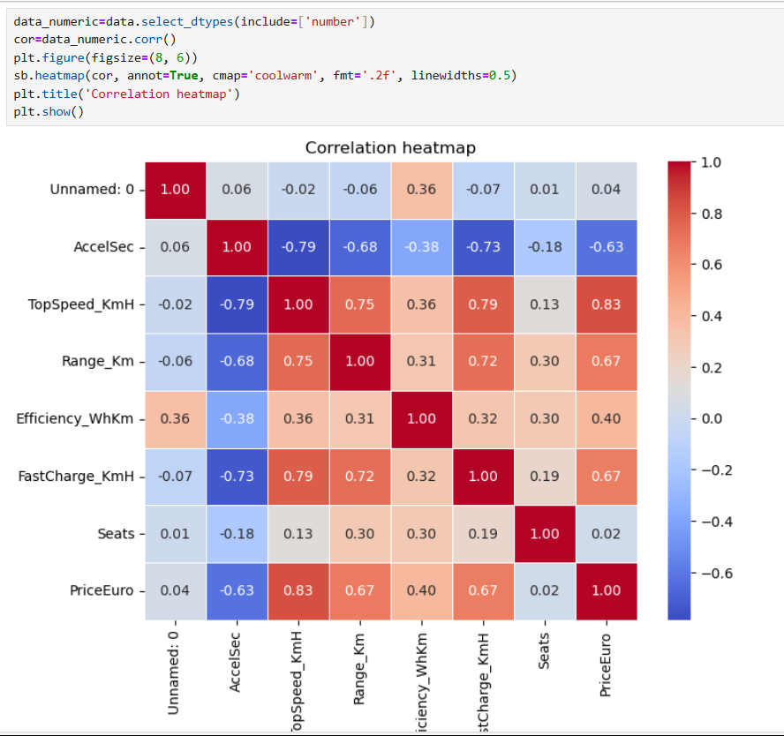

* + A strong positive correlation (0.83) exists between TopSpeed_KmH and PriceEuro, indicating that vehicles with higher top speeds tend to be more expensive.
  + Range_Km also correlates positively with PriceEuro (0.67), suggesting vehicles with higher ranges are pricier.
  + A strong negative correlation (-0.79) exists between AccelSec and TopSpeed_KmH, meaning vehicles with faster acceleration (lower seconds) tend to have higher top speeds.
  + Other notable relationships include Efficiency_WhKm negatively correlating with Range_Km (-0.68) and FastCharge_KmH positively correlating with TopSpeed_KmH.

**Image 2: Bar Plot (Brand vs PriceEuro)**

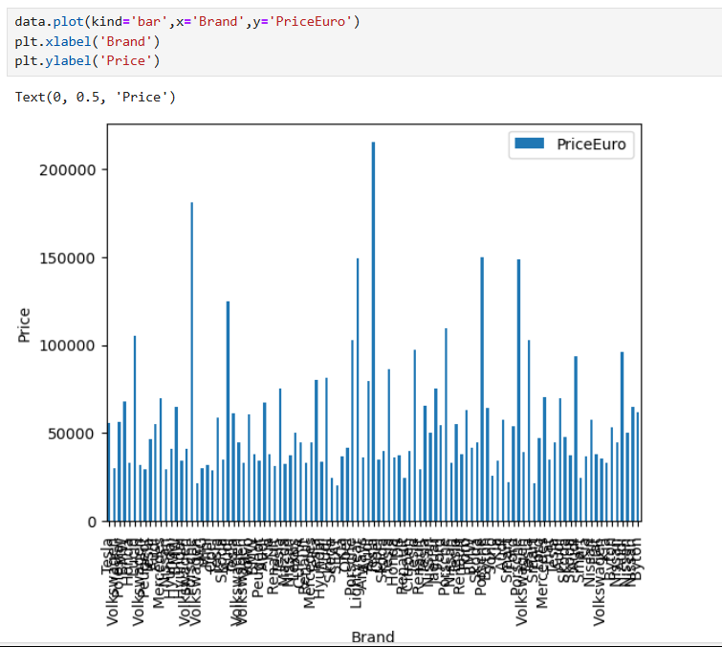

* The bar plot displays the PriceEuro distribution across different brands.
* Key Observations:
  + Prices vary widely between brands, with some brands offering premium vehicles priced above €200,000.
  + Many brands show a consistent pricing trend, while a few have large outliers, possibly indicating luxury or specialty vehicles.
  + The x-axis (Brand names) is cluttered due to the large number of brands, which could benefit from aggregation or filtering for clarity.

**Image 3: Scatter Plot (TopSpeed vs Range)**

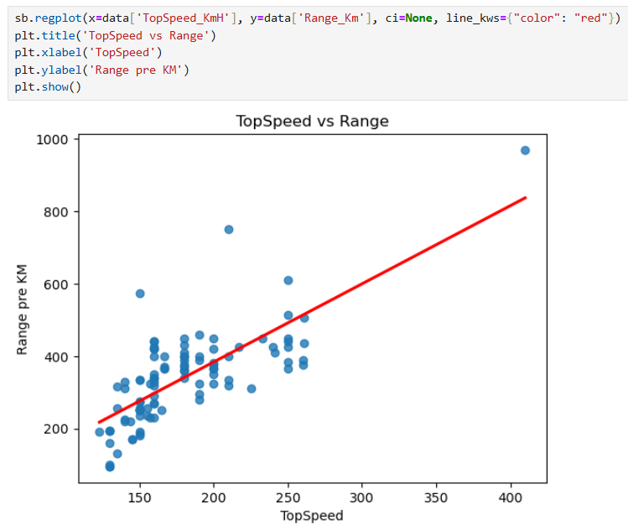

* This scatter plot with a regression line shows the relationship between TopSpeed_KmH and Range_Km.
* Key Observations:
  + There is a positive trend between top speed and range, as vehicles with higher top speeds tend to have longer ranges.
  + However, some outliers with extremely high ranges or top speeds deviate from the trend.
  + The regression line visually confirms this positive correlation, which aligns with the correlation value (0.75) seen in the heatmap.

**Image 4: Scatter Plot (Acceleration vs Efficiency)**

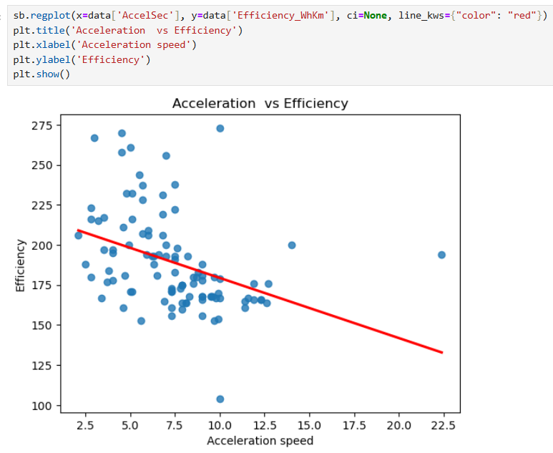

* This plot examines the relationship between AccelSec (acceleration time) and Efficiency_WhKm.
* Key Observations:
  + There is a negative trend, where vehicles with faster acceleration (lower seconds) tend to have lower efficiency (higher WhKm values).
  + The negative correlation reflects a trade-off between performance and energy efficiency.
  + This trend aligns with the correlation value (-0.38) from the heatmap, though the relationship is weaker compared to other variables.

**Image 5: Scatter Plot (TopSpeed vs Range - Simplified)**

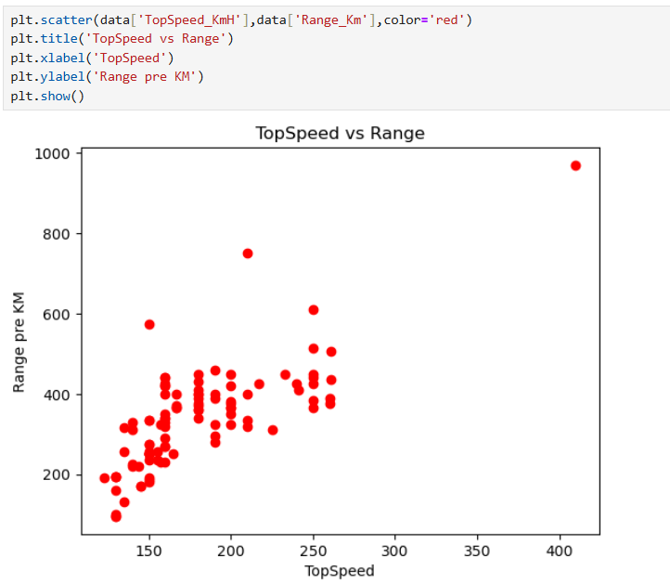

* A simpler version of the third plot, this scatter plot omits the regression line and focuses solely on data points.
* Key Observations:
  + The positive relationship between TopSpeed_KmH and Range_Km is evident.
  + Clusters of data points suggest that most vehicles fall within a specific range of speeds and ranges, with a few outliers.

**Conclusion:**

The Indian EV market is highly dynamic, offering a wide spectrum of vehicles tailored to diverse consumer needs. By analysing metrics such as range, efficiency, price, and performance, the study identifies the following critical insights:

1. **Market Trends:**
   * The SUV body style dominates, appealing to family and adventure-oriented buyers.
   * Compact and mid-segment EVs show high potential for mass adoption due to their affordability and practicality.
   * An increasing preference for vehicles with efficient energy consumption and longer ranges highlights consumer demand for sustainability and performance.
2. **Price Sensitivity:**
   * The market is segmented across affordable (<€35,000), mid-range (€35,000–€55,000), and premium (>€55,000) vehicles.
   * Despite the average price being €55,811, cost-effective models targeting the lower end of the price spectrum are essential to meet the needs of India's price-sensitive consumers.
3. **Technological Insights:**
   * High-speed and high-range EVs, such as the Tesla Model 3, cater to performance-focused consumers.
   * Rapid charging and energy efficiency are emerging as critical decision factors for EV buyers, emphasizing the need for advanced charging infrastructure.
4. **Gaps and Opportunities:**
   * Addressing affordability gaps is crucial to encourage widespread adoption among middle-income groups.
   * Infrastructure enhancements, particularly in charging networks, are necessary to support long-distance EV use.
   * Market players have opportunities to develop cost-optimized models and expand options in the compact and medium-range vehicle categories.
5. **Future Outlook:**
   * The strong positive correlation between price and performance metrics (e.g., range, top speed) indicates a growing market for premium vehicles. However, for mass adoption, manufacturers must prioritize affordable and practical EVs.
   * Collaboration between policymakers and industry stakeholders will be pivotal to overcoming infrastructural challenges and driving the transition to sustainable mobility.